

**COMMUNITY EQUIPMENT STORE CONDITIONS OF LOAN**

The equipment is on loan to the named serviced user, for their personal use – no one else should use the equipment without advice or assessment.

Please read and observe the content of any leaflets or instructions issued with your equipment.

If you or your carers are not sure about the use, precautions or cleaning of any item issued to you, please contact the referrer listed on the delivery note for any advice.

The equipment must only be used in a safe manner for the purpose it was designed and supplied and should not be modified in any way.

The equipment remains the property of CES whilst on loan and reasonable access should be granted to staff to service and Loler equipment if required. Please advise store of any change to address or telephone number.

Please treat this equipment responsibly. Within the life of the equipment normal wear and tear will be covered within reason. However misuse of equipment will not be covered for replacement and you may be liable for the cost of replacement, i.e. burns to covers or damaged/lost cables etc. If the equipment needs maintenance or replacement due to normal wear or tear please advise.

Equipment is on loan and should be returned when no longer required. All returned equipment, if suitable for refurbishment will be cleaned, inspected and returned to stock. The equipment store recycles an average of £1 million of equipment annually. To arrange a collection please contact us or return to store.

**CONTACT US:**

**Community Equipment Store, St John’s Hospital, Howden, Livingston, EH54 6PP**

**01506 280101 or e-mail** [ces@westlothian.gov.uk](mailto:ces@westlothian.gov.uk)

**Online** - **westlothianhscp.org.uk/equipment**

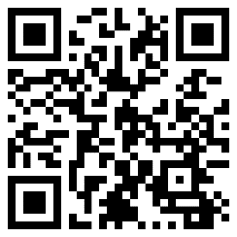

The community Equipment Store is available Monday to Thursday from 08:45 to 5pm and Friday 08:45 to 4pm

You can now [Request repeat continence products](https://forms.office.com/r/mG86t9j9au) online. You must already have an existing prescription in place to use this service.

**westlothianhscp.org.uk/continence**

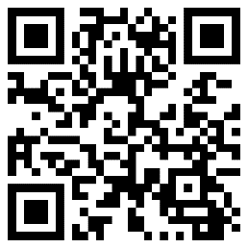

**FAULTY EQUIPMENT**

It is important that you inform the Equipment Store about any broken or faulty equipment as soon as possible. You should not use broken or faulty equipment until it has been repaired or replaced by the store.

During office hours please phone the store on 01506 280101. Please only phone Out of Hours for emergency requests.

**OUT OF HOURS**

|  |  |
| --- | --- |
| Equipment | Phone Number |
| Hospital beds, Powered Mattress & Cushions. Mobile Lifting Hoist | St John’s Switchboard - 01506 523000  On call engineer will visit |
| Stairlift & Ceiling Track Hoist | West Lothian Council Social Care Emergency Team 01506 281029 |
| Patient Owned Equipment | Patient’s responsibility, contact manufacturer. |

**OTHER USEFUL NUMBERS**

Wheelchairs – contact Astley Ainslie on 0131 537 9177

Red Cross – 03004561914

Home Safety Service – 01506 284440

Adult Social Care Enquiry Team (ASCET) - 01506 284848