Measuring Walking Aids

Walking Aids.
DISCLAIMER: these are general guidelines. It is the user’s responsibility if you have any problems with measuring or any concerns: please call your health professional who ordered your walk aid for advice.
Regularly check the rubber stopper (ferrule) for any signs of wear: replace when they start to wear down.

Why it's important to measure for a walking aid:
A walking aid which is the wrong height may cause discomfort.
If a walking aid is too long, there will be less support.
If a walking aid is too short can make you stoop or tilt.

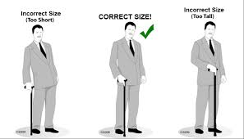

Measuring Elbow Crutches
DISCLAIMER: these are general guidelines. It is the user’s responsibility if you have any problems with measuring or any concerns: please call your health professional who ordered your walk aid for advice.
Regularly check the rubber stopper (ferrule) for any signs of wear: replace when they start to wear down.
Crutches should be at the correct height for use:
Stand in your regular footwear with your arms hanging relaxed.
Have someone measure the distance between the wrist crease and the ground. This should be the height of the hand grip of your walking aid.
Some elbow crutches also have an adjustment for the elbow cuff. This should cradle the forearm just below the elbow joint so that movement of the elbow is not prevented.
Press both small buttons in on the shaft then, slide the inner shaft up or down to the correct length and release the button into the correct holes: you will hear it click out again. Make sure the buttons are outside the shaft.

