Measuring Walking Aids

Walking Aids.
DISCLAIMER: these are general guidelines. It is the user’s responsibility if you have any problems with measuring or any concerns: please call your health professional who ordered your walk aid for advice.
Regularly check the rubber stopper (ferrule) for any signs of wear: replace when they start to wear down.

Why it's important to measure for a walking aid:
A walking aid which is the wrong height may cause discomfort.
If a walking aid is too long, there will be less support.
If a walking aid is too short can make you stoop or tilt.

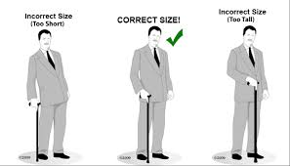

Measuring Walking Stick, Tripod, Quad
Stand in your regular footwear with your arms hanging relaxed.
Have someone measure the distance between the wrist crease and the ground.
This should be the height of the hand grip of your walking aid.

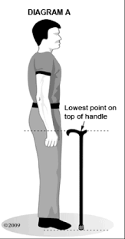
Height adjustable walking sticks, tripod, quad
Push in the small button on the stick shaft.
Then, slide the inner shaft up or down to the correct length and release the button into the correct hole: you will hear it click out again. Make sure the button is outside the shaft
Some sticks have a removable clip: remove-adjust-and replace clip in new hole.
